**Lesson 19: Volume of Rectangular Prisms**

**Do Now:**

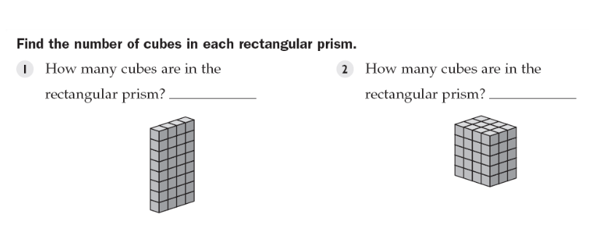

**Key Vocabulary:**

Volume is the amount of three-dimensional space that an object occupies.

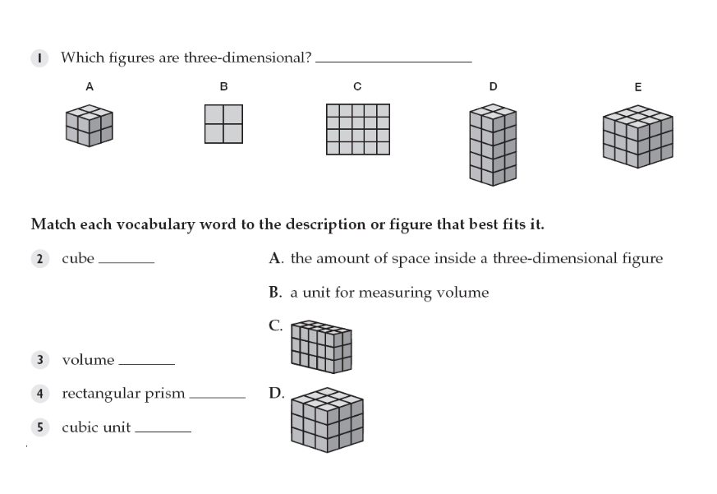

**Guided Notes:**

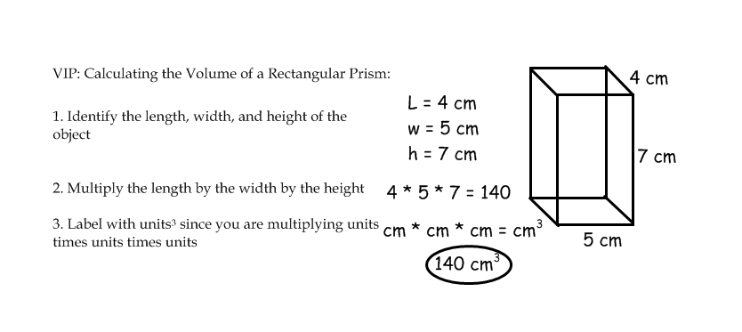

**OR: Volume is the base area times height. V = Bh**

**In the above example: base area is 5 cm * 4 cm = 20 cm2**

**So V = (20 cm2)*(7 cm) = 140 cm3.**

**REMEMBER YOUR UNITS!!**

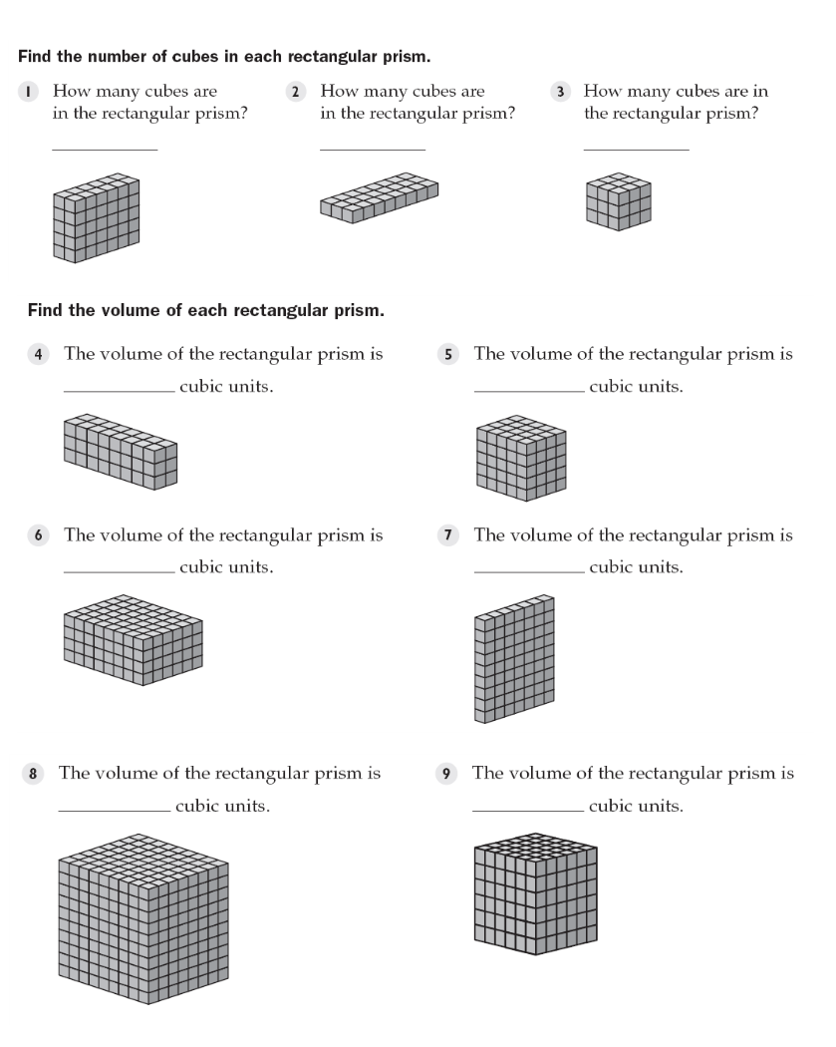

**Structured/Guided Practice:**

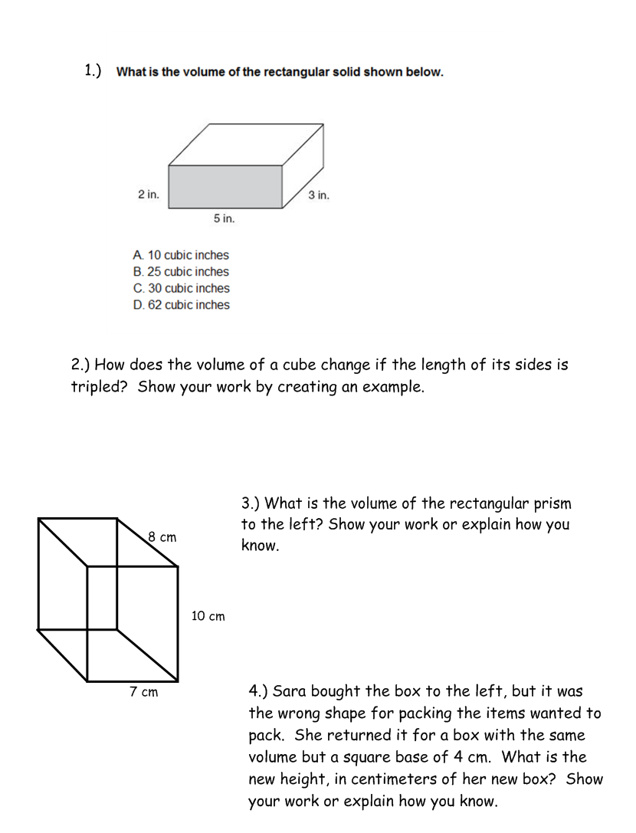

**Independent Practice:**

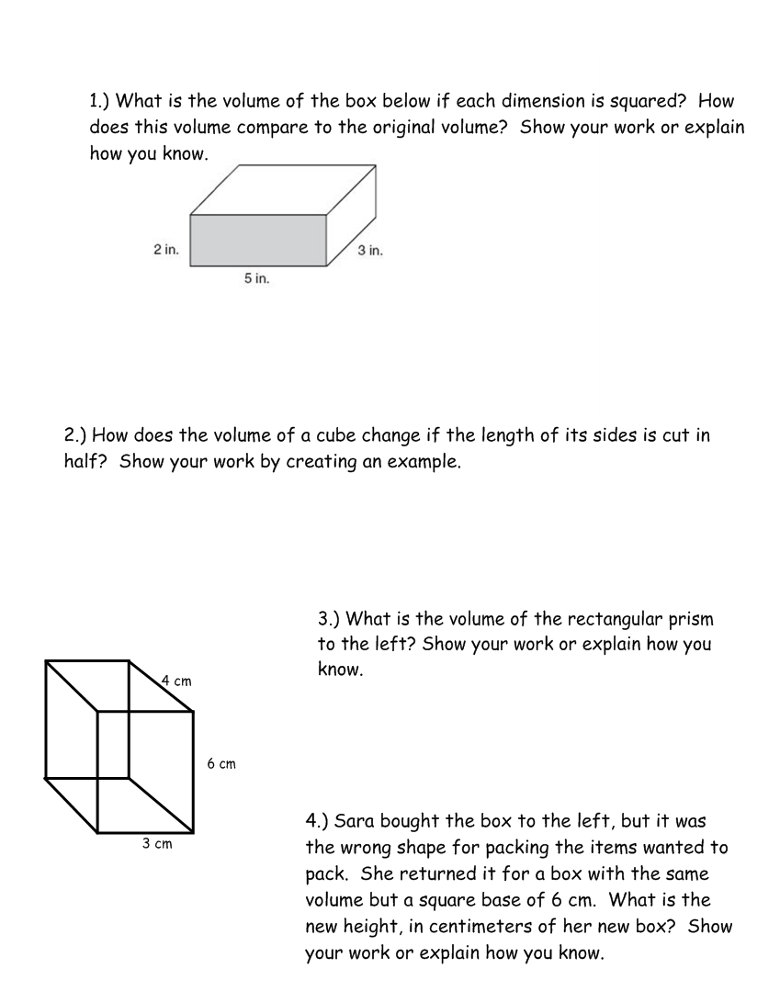

**Closure:**

